

Links :

1. Practical informational
2. Background
3. Team
4. Vision and Mission
5. Core values
6. Milestone
7. Insights / News
8. IT Services
9. Reach us
10. Opportunities



1. E-Visitors system
2. SAN TECH HUB
3. SANBOOK
4. Investment Opportunities
5. Inventiveness
6. Tel: +250783250033
7. Change languages



Invest in Tehnological products development

SAN TECH is a Smart technology delighted service provider with a vision to be a tech hub which develops digital technological products, which facilitate human daily activities, and develop talents for innovations and inventions to the Gross Domestic Products (GDP). SAN TECH develops automation products and equips youth and people in Digital unlocking innovation and career guidance to contribute to the national and regional ICT sector development. Technological products development is our daily life and We are also specialized in creating and delivering a variety of information management solutions.

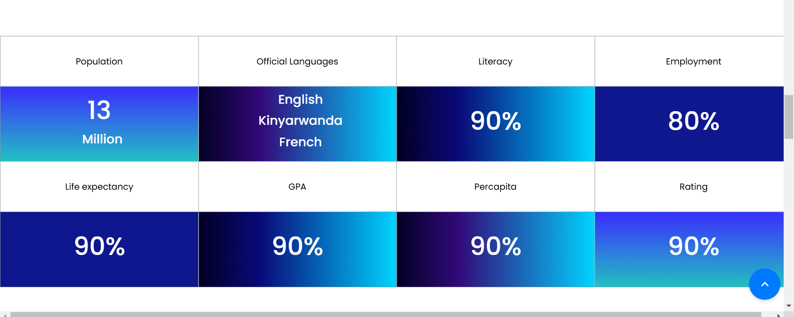

Clients Served

Official languages

E-Visitors system Beneficiaries

SAN TECH HUB Beneficiaries

Jobs created for Youth

Innovative ideas Developed

Partnerships

New business started due to SAN TECH HUB



**SAN TECH stretches**

Since our inception , Technological products development is our daily domain. Education Support activities is our daily career and enhancing youth to be self employment rather than seeking jobs with deeply thinking on uniqueness between what you wish to offer